Social media assets
Note from Become: Thank you for sharing and highlighting National Care Leavers’ Week, we really appreciate your support. The below examples are for Twitter but please feel free to tweak for other socials and tag us. Our Instagram is @BecomeCharity & Twitter @Become1992.
Example tweets:
- For National Care Leavers’ Week (#NCLW) @Become1992 & other orgs are asking you to ‘CARE’. Read more here: BecomeCharity.org.uk/NCLW

- It’s National Care Leavers’ Week #NCLW, get involved with the acronym and theme CARE.
You can ‘C’elebrate care leavers, ‘A’mplify their voices, ‘R’aise awareness of challenges and ‘E’ncourage change in policy and practice.
Read more: BecomeCharity.org.uk/NCLW
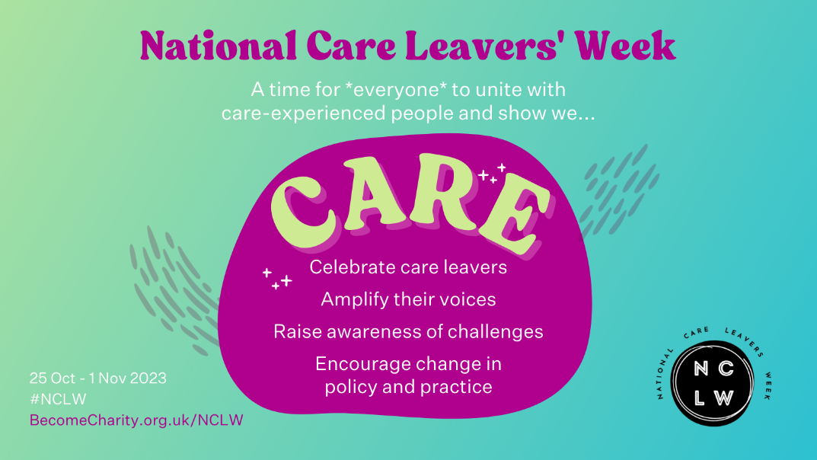

- It’s #NCLW and the first letter of the theme is ‘C’ for Celebrate care leavers. We are joining @Become1992 in celebrating care leavers. We want to celebrate [name] for [celebration]!
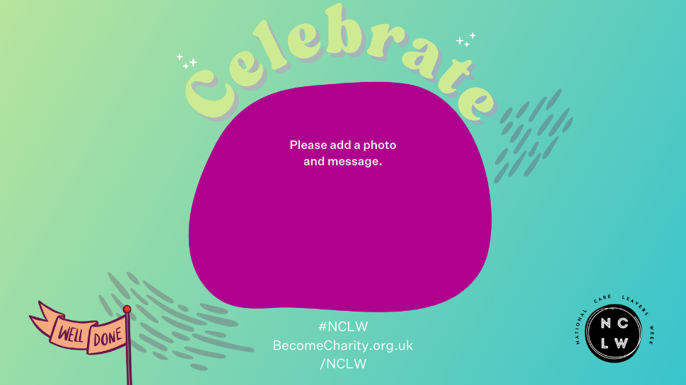

- It’s #NCLW and the second letter of the theme is ‘A’ for Amplify #CareExperienced voices. We are joining @Become1992 in listening to young people. Get a ticket to one of their webinars below: https://becomecharity.org.uk/become-the-movement/our-campaigns/national-care-leavers-week/#events
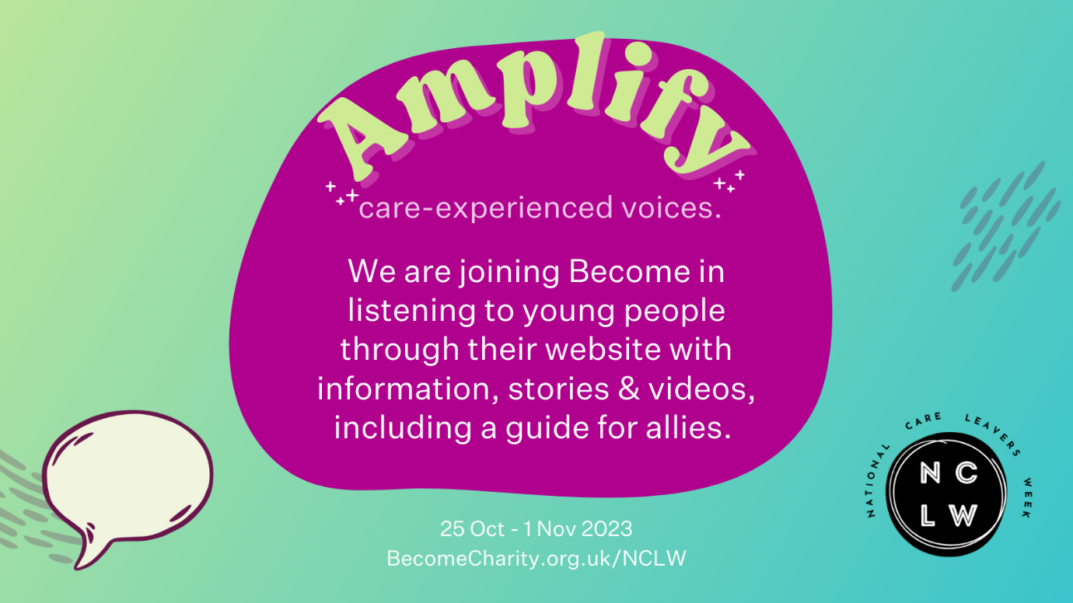

- It’s #NCLW and the third letter of the theme is ‘R’ for Raising awareness of challenges. Check out @Become1992’s socials for information on the #EndTheCareCliff campaign and what that means for young people.
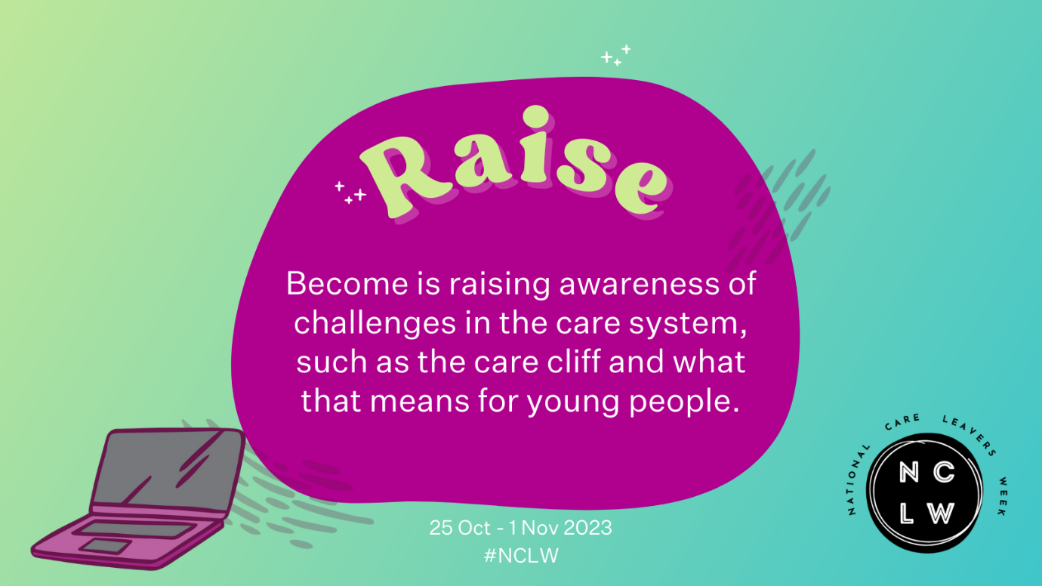

- It’s #NCLW and the 4th letter of the theme is ‘E’ for Encouraging change in policy & practice.

We are joining @Become1992 in calling for the Gov't to permanently #EndTheCareCliff and the expectation of ‘independence’ when turning 18. Join the campaign: https://becomecharity.org.uk/end-the-care-cliff
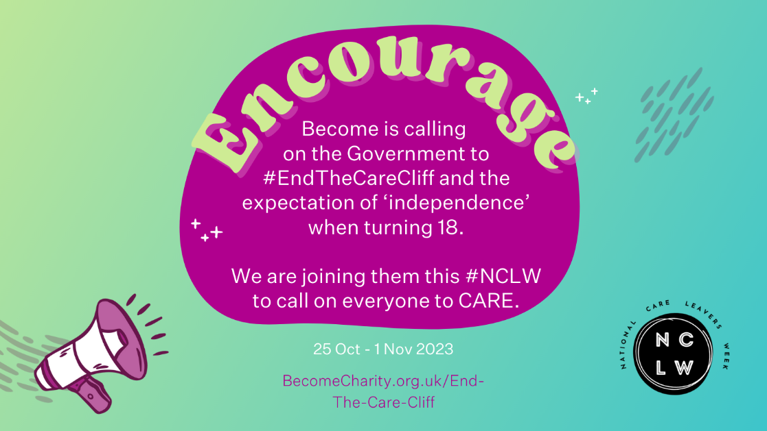

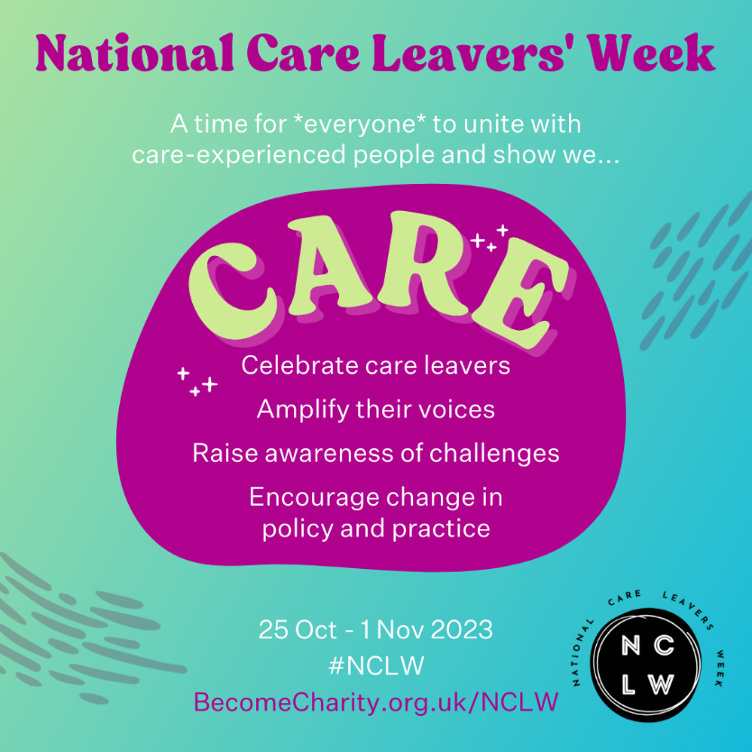
Square images for Instagram/other socials:

