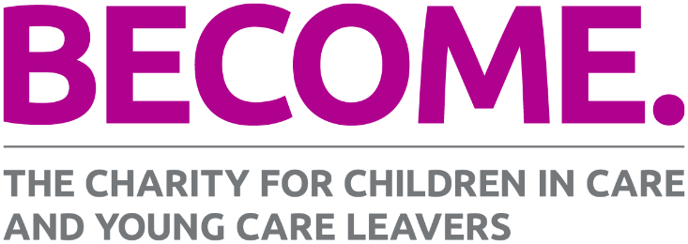
Press release
18/03/2024
Leslie Morphy, former CEO of Crisis, appointed Chair of Become, the national charity for children in care and young care leavers.
Leslie Morphy has been appointed the new Chair of Become. She is joined by Marvin Campbell, who will take up the role of Vice Chair.
Leslie brings a wealth of experience to the Become board from her time at Crisis, where she was CEO until 2015, and as a Director at The Princes Trust, where she worked with disadvantaged young people, including care leavers. She has held a number of other non-executive roles, including Chair of the Board at Oxford Brookes University, Senior Independent Director at an NHS mental health trust, and is currently the Chair for Pathway, a charity addressing homeless and inclusion health.
Marvin is a Senior Consultant at Deloitte where he supports the design and delivery of complex transformation programmes across the public sector. He brings a breadth of personal and professional experience of children's social care, and most recently supported engagement and the policy recommendations for care-experienced people as part of the Independent Review of Children's Social Care.
Leslie and Marvin join the Become board at a time when the care system is in crisis and there are more children in care than ever. They will be working with the Board and Become team to grow the charity’s impact and, as we look towards a general election, ensure the next Government delivers change for care-experienced children and young people.
Existing board members Andy Harris and Beth Taswell have been acting as interim co-chairs since former Chair Hugh Thornbery, CBE, stepped down from the Board last year.
Leslie Morphy, Become’s new Chair, says:
“I am thrilled to join Become as Chair. At a time when there are record numbers of children in care and a care system that is failing to provide the love, support and stability they need, the work of the charity is more urgent than ever.
“I look forward to supporting Become’s vital work with care-experienced young people and their campaigning for the changes to the care system that young people want to see.”
Marvin Campbell, Become’s new Vice Chair, says:
"I am honoured to be joining Become as Vice Chair, particularly at a time when investment and urgent action is needed to reform the care system. Having grown up in care I have seen first-hand the difficulties those with care experience face, and the vital role Become has had on children and young people and the wider system over the last 30 years.

“I hope to use my experience of policy and service transformation to help Become expand its reach and give care-experienced young people a stronger voice in shaping a care system that works for them.”
Katharine Sacks-Jones, CEO of Become, says:
“We are delighted to welcome Leslie and Marvin to the Become Board. Leslie has extensive experience of leadership and governance and a strong commitment to improving the lives of care-experienced young people. We are very excited about the positive impact we will have in the years ahead with Leslie’s support and guidance.
“We’re fortunate to also be joined by Marvin as Vice Chair who brings a huge amount of personal and professional experience to the board. We’re very grateful to Beth and Andy for stepping forward to co-chair Become in the interim period, which has included launching new services, producing a report with MPs and our Christmas appeal with the i Paper. Their leadership and support have been invaluable over the last six months.”
ENDS
For more information or to make a media enquiry, please contact Become’s Press and Media Officer, Suzy Barber, via 07951 155246 or suzy.barber@becomecharity.org.uk

About Become
Become is the national charity for children in care and young care leavers. We put young people at the heart of everything we do, supporting them to get the help they need now and empowering them to bring about change in their own lives, the care system and society.

To find out more, visit www.BecomeCharity.org.uk

